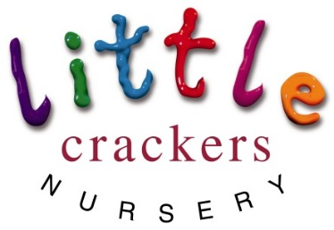
Weekly News

3rd May 2019

Nursery notices:  It’s that time of the year again when we all hope for some good weather… with that in mind can I just remind everyone about the need for suncream. We recommend you cover your child with an all day cream before coming to nursery, and then leaving a named bottle so we can top up as necessary. Please also send in a named hat that can stay in nursery.  Can I also reassure parents that while we understand the importance of outdoor play, we also adhere closely to NHS guidelines regarding time spent in the sun at the hottest times of the day. We will avoid the middle of the day and on especially hot days may have to spend more time inside enoying the air conditioning! |  | Dates to remember:  Don’t forget Bank Holiday this weekend – don’t come in on Monday!!!  Half term (term time children)  Mon 27th May-Mon 3rd June  SPORTS DAY!!!  Thursday 13th June 9.30am  PRE-SCHOOL GRADUATION!!!  Tuesday 25th June (afternoon)  School closes for the Summer  (term time children)  Wednesday 3rd July
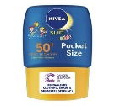
Joke of the week:  What is black and white and red all over?  A sunburnt zebra! | Message from Mrs Bird:  To parents of the pre-school children,  Please can you let her know as soon as possible when your child’s last day in nursery will be so that the billing will be accurate.  Thank you x |  | Unfortunately for some, but fortunately for others, our Dramatots slot has changed… we will now see Sam for adventures on a Monday afternoon.  My apologies to those who will now miss it.
Little Crackers Nursery · Crackley Hall · St Joseph’s Park · Kenilworth · CV8 2FT
Telephone: 01926 514444 · Fax: 01926 514455 · e-mail: littlecrackers@crackleyhall.co.uk
www.crackleyhall.co.uk

Registered Charity Number 1087124 Company limited by guarantee Number 4177718

You can email Mrs Bird clarebird@crackleyhall.co.uk
or ring the nursery direct 01926 514456

